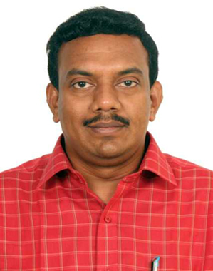 Main Page

Dr LOGANATHAN RANGASAMY

Associate Professor

DBT Ramalingaswami Re-entry Fellow

Centre for Biomaterials, Cellular and Molecular Theranostics (CBCMT)

ALM Building, Room No. 403

Vellore Institute of Technology (VIT)

Vellore - 632 014, Tamil Nadu, India

Email: loganathan.r@vit.ac.in

Google Scholar: <https://scholar.google.com/citations?user=L80u9LMAAAAJ&hl=en>

Research Interest

* Medicinal Chemistry
* Drug Design and Discovery
* Ligand-Targeted Drug Conjugates
* Chemical Biology
* Molecular Imaging Agents (Fluorescence, NIR, and radio imaging)
* Immunotherapy
* Antimicrobial Agents

Educational Qualifications

BSc (Chemistry) **PSG College of Arts and Science, Bharathiar University,** India 2003 – 2006

MSc (Chemistry) **PSG College of Arts and Science, Bharathiar University**, India 2006 – 2008

PhD (Chemistry) Bharathidasan **University, Tiruchirappalli, India 01/2009 – 04/2014**

Thesis Title: “*Studies on DNA and Protein Cleavage and Anticancer Activities of Mixed Ligand Copper(II) Complexes of Diimines, supervised” by Prof. M. Palaniandavar FASc, FRSC, FNA, INSA-Senior Scientist, DST-SERB Fellow, School of Chemistry, Bharathidasan University, India.*

Professional Experience

**Postdoctoral Fellow**, research group of Prof. Gilles Gasser, **University of Zurich, Switzerland,** supported by a Swiss Government Excellence Scholarship 09/2014 – 09/2015

**Postdoctoral Research Associate**, research group of Prof. Philip S Low, **Purdue University, Purdue Institute for Drug Discovery, United States**  01/2016- 12/2017

**Marie Skłodowska-Curie Individual Postdoctoral Fellow** at **University of San Pablo CEU, Madrid, Spain** under the supervision of Prof. Ana Ramos and Prof. Beatriz de Pascual-Teresa Fernández 04/2018- 01/2020

**DBT Ramalingaswami Re-entry Fellow**, **Centre for Biomaterials, Cellular and Molecular Theranostics (CBCMT), Vellore Institute of Technology (VIT**) 02/2020-11/2022

**Associate Professor Grade I, Centre for Biomaterials, Cellular and Molecular Theranostics (CBCMT), Vellore Institute of Technology (VIT)** 11/2022- Till date

Group Members

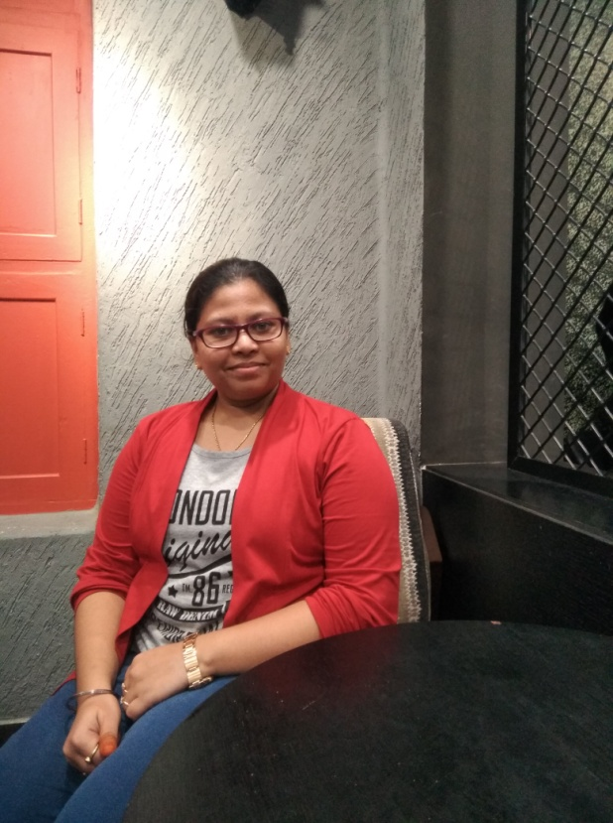

DHANASHREE MURUGAN

Ph.D. Research Scholar (19PHD0027)

Centre for Biomaterials, Cellular, and Molecular Theranostics (CBCMT)

Vellore Institute of Technology (VIT)

Vellore-632014

Email: dhanashree.murugan2019@vitstudent.ac.in

Date of Joining: 21.09.2019

Dhanashree Murugan is a Ph.D. scholar at the Vellore Institute of Technology (VIT). She had completed her Master's and Bachelor's in Biotechnology from SIES College of Arts, Science, and Commerce, Mumbai. She also has experience in working in areas like molecular biology and biophysical studies on proteins. She has been actively associated with the "Drug Discovery Unit (DDU)" since its birth in the Centre for Biomaterials, Cellular, and Molecular Theranostics (CBCMT) at VIT. Her area of research is based on "Designing and synthesizing Cancer stem cell-targeted drug for cancer". Her long-term goal is to translate her research into a marketable product that could be helpful for the welfare of society. She is also passionate about focusing her research on the fabrication of cancer-on-chip, which could be a platform for synthesizing personalized medicine based on the patient's cancer cells and immune status.

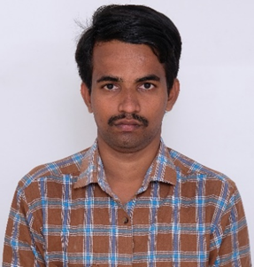

Harashkumar V T

Ph.D. Research Scholar (20PHD0444)

Centre for Biomaterials, Cellular, and Molecular Theranostics (CBCMT)

Vellore Institute of Technology (VIT)

Vellore-632014

Email: [harashkumar.vt2020@vitstudent.ac.in](mailto:harashkumar.vt2020@vitstudent.ac.in)

Date of Joining: 09.09.2020

Harashkumar Vasanthakumari Thirumalaiswamy joined Drug Discovery Unit (DDU) as a Ph.D., scholar on 9th September 2020. He worked as an Assistant Professor (Junior), the Department of Chemistry, School of Advanced Sciences (SAS), Vellore Institute of Technology (VIT), Vellore, Tamil Nadu, India for a period of 3 years from April 2021 to March 2024. He has completed a master’s and bachelor’s in chemistry at Chikkanna government arts college (Affiliated to Bharathiar University, Coimbatore). During his post-graduation, he worked as a part-time technical analyst in the Chemical Section of the Azo textile testing laboratory, Tirupur. He also has expertise in the chemical analysis field. His current research focused on the synthesis of NIR fluorescent imaging agents for the diagnosis of cancer and the development of small molecule-based proteolysis targeting chimeras (PROTACs) for cancer therapy. Recently, he went on an internship at WML lab, Department of Chemistry, Fu Jen Catholic University, Taiwan under the International Internship Pilot Program (IIPP) as a scholar fellow for a period of 3 months from October 2023 to December 2023.

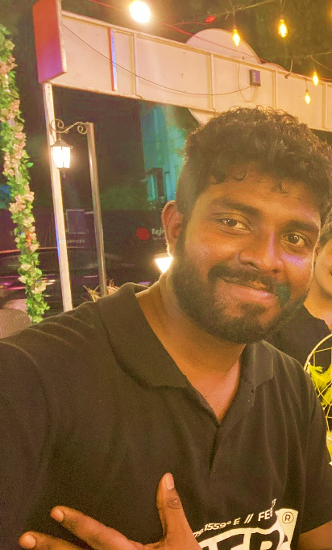

UNNIKRISHNAN B

PhD Research Scholar (22PHD0475)

Centre for Biomaterials, Cellular, and Molecular Theranostics (CBCMT)

Vellore Institute of Technology (VIT)

Vellore-632014

Email: [unnikrishnan.b2022@vitstudent.ac.in](mailto:unnikrishnan.b2022@vitstudent.ac.in)

Date of Joining: 12-08-2022

Unnikrishnan B, completed his post-graduation in chemistry in 2019 Feb from the University of Kerala. After that, he worked as a radio chemist at Molecular Cyclotron Pvt Ltd, Vypin Kochin, Kerala. After that, he worked as a Junior Research fellow at IIT Bhilai. Then he joined Vellore Institute of Technology (VIT) as a Junior Research Fellow (JRF) on the “BRNS Project Radiolabelled Fibroblast Activation Protein Inhibitors as Novel Radiopharmaceuticals Targeting CAFs”. Later he joined Ph.D. in VIT under the School of Advanced Sciences. His main hobbies include reading, writing short stories, watching movies, and traveling. He is passionate about translating science into products and ideas for human welfare.

Ph.D. Title: “Design, Synthesis, and Biological Evaluation of Novel Receptor Targeted Photodynamic Therapeutics for Anti-Cancer Therapy”

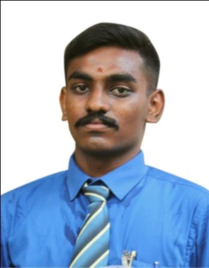

Name: KALAIARASU L

PhD Research Scholar (22PHD0515)

Centre for Biomaterials, Cellular, and Molecular Theranostics (CBCMT)

Vellore Institute of Technology (VIT)

Vellore-632014

Email: kalaiarasu.l2022@vitstudent.ac.in

Date of Joining: 11-01-2023

Write up:

Kalaiarasu L. joined the Drug Discovery Unit (DDU), Centre for Biomaterials, Cellular and Molecular Theranostics (CBCMT), VIT, as a doctoral student with a Teaching cum Research Assistant (TRA) fellowship on 11th January 2023. He is currently working as Project Research Scientist I (Non-Medical) on the ICMR-funded project titled “Design and Development of Siderophore-Macrolide Antibiotic Conjugates to Combat Multidrug Resistance (MDR) Gram-Negative Bacterial Infections” at DDU, CBCMT. He graduated with his Master’s in Chemistry from the School of Chemistry, Bharathidasan University (BDU), Tiruchirappalli, India in 2021. For his Master’s dissertation, he worked on the project titled “Synthesis of 3-Arylquinoxaline from Aroylmethylidene

Malonate and Ortho-Phenylenediamine” under the guidance of Prof. Dr. Srinivasan K. Synthetic Organic Lab, School of Chemistry, Bharathidasan University (BDU), Tiruchirappalli, India. He obtained his second Master’s in Business Administration Finance (Twinning program) from Pondicherry University in 2021. He obtained his Bachelor’s in Chemistry from Bishop Heber College (Autonomous), Tiruchirappalli, India. For his Bachelor’s dissertation, he worked on the project “Multiresidue determination of pesticides in fruits and vegetables by Gas Chromatography – Triple Quadrupole Mass Spectrometry”. During his bachelor’s, he has undergone internships at the National Referral Lab, ICAR-National Research Centre for Grapes (NRCG), Pune, India. Bio-Prospecting Division, Institute of Forest Genetics and Tree Breeding (IFGTB), Coimbatore, India. Analytical Lab, The South India Textile Research Association (SITRA), Coimbatore, India. Before joining DDU, he worked as a Technical Assistant at the National Centre for Avian Ecotoxicology, Sálim Ali Centre for Ornithology and Natural History (SACON), Ministry of Environment, Forest & Climate Change, Government of India. His area of interest include Antimicrobial Resistance (AMR), Drug Delivery, Biological and Medicinal Chemistry

Short title of PhD work: Design of Targeted Therapeutic Agents for the Diagnosis and Treatment of Bacterial Infections.

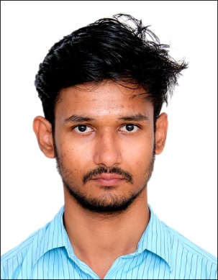

Name: Janarthanan Venkatesan

PhD Research Scholar (22PHD0389)

Centre for Biomaterials, Cellular, and Molecular Theranostics (CBCMT)

Vellore Institute of Technology (VIT)

Vellore-632014

Email ID : janarthanan.v@vit.ac.in

Date of Joining: 01.08.2022

Write-up: Janarthanan Venkatesan joined the Drug Discovery Unit (DDU), as a Teaching cum Research Assistant (TRA) on 1st August 2022. His area of interest includes medicinal chemistry and targeted protein degradation in cancer therapeutics. He is currently working under the guidance of Dr. Loganathan Rangasamy, at Vellore Institute of Technology (VIT), on the development of molecules for the proteasome-mediated degradation of oncogenic proteins. He has also undergone an International Internship Pilot Program (IIPP) and worked on 3D cell culture models for the study of cancer metabolism in PDAC tumours, under Dr. Ching-Feng Chiu, Taipei Medical University (TMU), sponsored by the National Science and Technology Council, Taiwan. His master’s thesis was on the development of bio-polymeric sorbents for the removal of heavy metals in the aquatic system, at J.K.K. Nataraja College of Arts and Science, under Dr. V. Gopalakannan, followed by a summer internship (2022) on electrochemical detection of heavy metal pollutants, at Institute of Minerals and Materials Technology (IMMT), Bhubaneshwar.

Title of the PhD work: “Design and development of Proteolysis Targeting Chimeras (PROTACs) for the degradation of oncogenic proteins”

Awards and achievements

Students Achievements

1. Druggathon Winter 2023 challenge by Bio Solve it – Phase II of challenge

Project name: “Design and Development of a Fibroblast Activation Protein Inhibitor”.

1. Ultrafast detection of urinary tract infections using paper-based nano-optoelectronic nose (P-NOEN) sensor, Student Startup Venture (SSV) - Mr. Kalaiarasu L, (22PHD0027), Mr. Harashkumar V T, (20PHD0444) and Mr. Unnikrishnan B, JRF, (22PHD0475)

Total Coast: 2 lakhs Funding Agency: VIT Vellore Duration: 2024 -2025

1. Mr. Harsh Kumar V T (20PHD0444) had been selected for International Internship Pilot Program (IIPP) as a scholar fellow for a period of 3 months from October 2023 to December 2023 at WML lab, Department of Chemistry, Fu Jen Catholic University, Taiwan.
2. Mr. Janarthanan V (22PHD0389) has also undergone an International Internship Pilot Program (IIPP) and worked on 3D cell culture models for the study of cancer metabolism in PDAC tumours, under Dr. Ching-Feng Chiu, Taipei Medical University (TMU), sponsored by the National Science and Technology Council, Taiwan.
3. Peptide-conjugated drug delivery for targeting Breast cancer stem cells. Cancer Hackathon conducted by Karpagam Academy of Higher Education, Startup TN.

Total Coast: 0.25 lakhs Funding Agency: Karpagam Academy of Higher Education Duration: 2023 -2023

1. Low-cost, Portable, Peroxidase-Active, Visual Read-out Cytosensors for the Detection of Circulating Tumor Cells. Student Startup Venture 1st Edition-October 2022 - Dhanashree Murugan (19PHD0027), Janarthanan Venkatesan (22PHD0389), Shobana S (22PHD0208)

Total Coast: 0.4 lakhs Funding Agency: VIT Vellore Duration: 2022 -2023

Project Name:

Faculty Achievements

2024: **Faculty Startup Venture (FSV)** – VIT Vellore

2024: **ICMR Investigator-Initiated Research** - Small Extramural Grants Research Grant

2022: **BRNS Coordinated Research Project (CRP) –** Research Grant

2020: **DST-SERB-Core Research Grant Duration**, DST – INDIA

**VIT Seed Grant**, VIT Vellore

2019: **VIT Seed Grant**, VIT Vellore

2019: **DBT Ramalingaswami Re-entry Fellowship, DBT India**

2016: **Marie Skłodowska-Curie Individual Postdoctoral Fellowship** (H2020-MSCA-IF-2016-

European Commission), University of San Pablo CEU, Madrid, Spain

2014: **Swiss Government Excellence Scholarship for Postdoctoral Fellow,** Switzerland

2012: *CSIR Senior Research Fellowship (****CSIR-SRF****). New Delhi, India*

2011: ***Best Poster Award and Cash Award*** at the *Asian Conference on Coordiation Chemistry*

*(ACCC3), IIT Kanpur, India, October 17-20, 2011.*

2009: ***Best Poster Award*** *at the Symposium on Advanced Biological Inorganic Chemistry (SaBIC)*

*Tata Institute of Fundamental Research (TIFR), Mumbai, India, Nov 2-7, 2009.*

2009: ***Best Poster Award*** *at the International Conference on Coordination and Organometallic*

*Chemistry, (ICCC) Bharathiar University, Coimbatore, India, March 19 – 21, 2009*

Publication List

2024

1. *Synthesis and study of antibiofilm and antivirulence properties of flavonol analogues generated by palladium-catalyzed ligand-free Suzuki–Miyaura coupling against Pseudomonas aeruginosa PAO1,* ATBenny, M Thamim, P Srivastava, S Suresh, K Thirumoorthy, L Rangasamy, S Karthikeyan Easwaran, EK Radhakrishnan, RSC Advances, 2024, 14(18):12278-12293. doi: [https://doi.org/10.1039/d3ra08617h.( Impact](https://doi.org/10.1039/d3ra08617h.(%20Impact) Factor 3.9)

2023

1. *Pooled evidence from preclinical and clinical studies for stem cell-based therapy in ARDS and COVID-19*, D Murugan, L Rangasamy, 2022, Molecular and Cellular Biochemistry, 1-32, https://doi.org/10.1007/s11010-022-04601-2 (Impact Factor 3.842)
2. *Rational Design of Diphenyl-Λ5σ4-Phosphinine Based Fluorescent Probe for the Selective Detection of Hg2+ Ions: Real Application in Cell Imaging and Paper Strips*, S Kulathu Iyer, S Enbanathan, S Manickam, M Dhanthala Thiyagarajan, **L Rangasamy,** **2022**, Journal of Photochemistry and Photobiology A: Chemistry, 437, 2023, 114431, <https://doi.org/10.1016/j.jphotochem.2022.114431> (Impact Factor 5.141)
3. *A perspective to weaponize microRNAs against lung cancer*, D Murugan, **L Rangasamy**, Non-coding RNA Research, 8, 2023, 18-32, <https://doi.org/10.1016/j.ncrna.2022.09.009> (Impact Factor - 5.00)
4. *Mixed ligand copper (ii)-diimine complexes of 2-formylpyridine-N 4-phenylthiosemicarbazone: diimine co-ligands tune the in vitro nanomolar cytotoxicity,* R. Kartikeyan, D. Murugan, T.Ajaykamal, M.Varadhan, L Rangasamy, M Velusamy, M Palaniandavar, V Rajendiran, Dalton Transactions, 2023,**52**, 9148-9169, <https://doi.org/10.1039/D3DT00213F> (Impact Factor 4.569)

**2022**

1. *The use of antimicrobial biomaterials as a savior from post-operative vascular graft-related infections: A review*, D Murugan, **L Rangasamy**, Results in Engineering, 100662, **2022**, <https://doi.org/10.1016/j.rineng.2022.100662> (Impact Factor 5.00)
2. *A perspective on newly emerging proteolysis-targeting strategies in antimicrobial drug discovery,* J Venkatesan, D Murugan, L Rangasamy, Antibiotics 2022, 11(12), 1717 <https://doi.org/10.3390/antibiotics11121717> (Impact Factor 5.222)
3. *Nanoparticle Enhancement of Natural Killer (NK) Cell-Based Immunotherapy*, D Murugan, V Murugesan, B Panchapakesan, **L Rangasamy**, Cancers 14 (21), 5438, **2022**, <https://doi.org/10.3390/cancers14215438> (Impact Factor 6.525)
4. *Recent developments of aptamer-based lateral flow assays for point-of-care (POC) diagnostics*, A Jaisankar, S Krishnan, **L Rangasamy**, Analytical Biochemistry, 114874, **2022**, <https://doi.org/10.1016/j.ab.2022.114874>, (Impact Factor 3.191)
5. *Can 3D-Printed Bioactive Glasses Be the Future of Bone Tissue Engineering?*, A Dukle, D Murugan, AJ Nathanael, **L Rangasamy**, TH Oh, Polymers 14 (8), 1627, **2022**, <https://doi.org/10.3390/polym14081627>, (Impact Factor 4.967)

2021

1. *Design and synthesis of water-soluble and potent MMP-13 inhibitors with activity in human osteosarcoma cells*, JM Zapico, L Acosta, M Pastor, **L Rangasamy**, L Marquez-Cantudo, ..., International journal of molecular sciences 22 (18), 9976, 2021, <https://doi.org/10.3390/ijms22189976>, (Impact Factor 6.208)
2. *Synthesis and Biological Evaluation of Metallocene-Tethered Peptidyl Inhibitors of CDC25*, S Roy, **L Rangasamy**, A Nouar, C Koenig, V Pierroz, S Kaeppeli, S Ferrari, ...Organometallics 40 (15), 2716-2723, **2021**, <https://doi.org/10.1021/acs.organomet.1c00345>, (Impact Factor 3.837)

2020

1. *New dual CK2/HDAC1 inhibitors with nanomolar inhibitory activity against both enzymes, L Rangasamy*, I Ortín, JM Zapico, C Coderch, A Ramos, ...ACS medicinal chemistry letters 11 (5), 713-719, **2020**, <https://doi.org/10.1021/acsmedchemlett.9b00561> (Impact Factor 4.632)

2019

1. *Molecular Imaging Probes based on Matrix Metalloproteinase Inhibitors (MMPIs)*, R. Loganathan, D. G. Bruno, O. Irene, C. Claire, J. M. Zapico, A. Ramos and ..., Molecules 24, 2982, **2019**, <https://doi.org/10.3390/molecules24162982> (Impact Factor 4.927)
2. *Enhancing microRNA activity through increased endosomal release mediated by nigericin*, EA Orellana, AM Abdelaal, L Rangasamy, S Tenneti, S Myoung, PS Low, ..., Molecular Therapy-Nucleic Acids 16, 505-518, **2019**, <https://doi.org/10.1016/j.omtn.2019.04.003> (Impact Factor 10.183, Cover page)

2018

1. *New Mechanism for Release of Endosomal Contents: Osmotic Lysis via Nigericin-Mediated K+/H+ Exchange*, L Rangasamy, V Chelvam, AK Kanduluru, M Srinivasarao, NA Bandara, ...Bioconjugate chemistry 29 (4), 1047-1059, **2018**, <https://doi.org/10.1021/acs.bioconjchem.7b00714> (Impact Factor 6.069)

2017

1. *DNA and protein binding, double-strand DNA cleavage and cytotoxicity of mixed ligand copper (II) complexes of the antibacterial drug nalidixic acid*, R Loganathan, M Ganeshpandian, NSP Bhuvanesh, M Palaniandavar, ..., Journal of inorganic biochemistry 174, 1-13, **2017**, <https://doi.org/10.1016/j.jinorgbio.2017.05.001> (Impact Factor 4.336)
2. FolamiRs: Ligand-targeted, vehicle-free delivery of microRNAs for the treatment of cancer, EA Orellana, S Tenneti, L Rangasamy, LT Lyle, PS Low, AL Kasinski, Science translational medicine 9 (401), eaam9327, 2017, <https://doi.org/10.1126/scitranslmed.aam9327> (Impact Factor 19.319)
3. *Abstract LB-332: FolamiRs: Ligand-targeted, vehicle-free microRNA replacement therapy*, EA Orellana, S Tenneti, L Rangasamy, PS Low, AL Kasinski, Cancer Research 77 (13_Supplement), LB-332-LB-332, **2017**, <https://doi.org/10.1158/1538-7445.AM2017-LB-332>
4. *Water soluble Ru (II)–arene complexes of the antidiabetic drug metformin: DNA and protein binding, molecular docking, cytotoxicity and apoptosis-inducing activity*, D Gopalakrishnan, M Ganeshpandian, R Loganathan, NSP Bhuvanesh, ...RSC advances 7 (60), 37706-37719, **2017**, <https://doi.org/10.1039/c7ra06514k> (Impact Factor 4.036)

2016

1. *Organometallic derivatization of the nematocidal drug monepantel leads to promising antiparasitic drug candidates*, J Hess, M Patra, L Rangasamy, S Konatschnig, O Blacque, A Jabbar, ..., Chemistry–A European Journal 22 (46), 16602-16612, *2016*, <https://doi.org/10.1002/chem.201602851> (Impact Factor 5.020)
2. *Synthesis, characterization and biological evaluation of novel Ru (II)–arene complexes containing intercalating ligands*, S Nikolić,# L Rangasamy,# N Gligorijević, S Aranđelović, S Radulović, ...Journal of Inorganic Biochemistry 160, 156-165, **2016**, <https://doi.org/10.1016/j.jinorgbio.2016.01.005> #These authors equally contributed. (Impact Factor 4.336)

2015

1. *Mixed ligand copper (II) dicarboxylate complexes: the role of co-ligand hydrophobicity in DNA binding, double-strand DNA cleavage, protein binding and cytotoxicity*, R Loganathan, S Ramakrishnan, M Ganeshpandian, NSP Bhuvanesh, ...Dalton Transactions 44 (22), 10210-10227, **2015**, <https://doi.org/10.1039/c4dt03879g> (Impact Factor 4.569)

2014

1. *Mixed ligand μ-phenoxo-bridged dinuclear copper (II) complexes with diimine co-ligands: efficient chemical nuclease and protease activities and cytotoxicity,* R Loganathan, S Ramakrishnan, E Suresh, M Palaniandavar, ... Dalton Transactions 43 (16), 6177-6194, **2014**, <https://doi.org/10.1039/c3dt52518j> (Impact Factor 4.569)
2. *New ruthenium (II) arene complexes of anthracenyl-appended diazacycloalkanes: effect of ligand intercalation and hydrophobicity on DNA and protein binding and cleavage and* … M Ganeshpandian, R Loganathan, E Suresh, A Riyasdeen, MA Akbarsha, ...Dalton Transactions 43 (3), 1203-1219, **2014**, <https://doi.org/10.1039/c3dt51641e> (Impact Factor 4.569)

2013

1. *Interaction of mixed ligand copper (II) complexes with CT DNA and BSA: Effect of primary ligand hydrophobicity on DNA and protein binding and cleavage and anticancer activities*, M Ganeshpandian, R Loganathan, S Ramakrishnan, A Riyasdeen, ..., Polyhedron 52, 924-938, **2013**, <https://doi.org/10.1016/j.poly.2012.07.021> (Most cited article 2013-2014) (Impact Factor 2.975)
2. *Copper (II) complexes with 2NO and 3N donor ligands: synthesis, structures and chemical nuclease and anticancer activities*, C Rajarajeswari, R Loganathan, M Palaniandavar, E Suresh, ...Dalton Transactions 42 (23), 8347-8363, **2013**, <https://doi.org/10.1039/c3dt32992e> (Impact Factor 4.569)

2012

1. *Mixed Ligand Copper(II) Complexes of N,N-Bis(benzimidazol-2-ylmethyl)amine (BBA) with Diimine Co-Ligands: Efficient Chemical Nuclease and Protease* … R Loganathan, S Ramakrishnan, E Suresh, A Riyasdeen, MA Akbarsha, ...Inorganic chemistry 51 (10), 5512-5532, **2012**, <https://doi.org/10.1021/ic2017177> (Impact Factor 5.436)

2011

1. *Interaction of copper (II) complexes with bis (p-nitrophenyl) phosphate: Structural and spectral studies,* T Dhanalakshmi, R Loganathan, E Suresh, H Stoeckli-Evans, ..., Inorganica Chimica Acta 372 (1), 237-242, **2011**, <https://doi.org/10.1016/j.ica.2011.02.030> (Impact Factor 3.118)

Book Chapters

1. **Book Chapter:** *3D Printing Technology for Fighting COVID-19 Pandemic,* **Book Name:** *Emerging Applications of 3D Printing During CoVID 19 Pandemic* pp 81-109, Rohin Shyam, Pearlin Hameed. Suya Prem Anand, Loganathan Rangasamy, Arunkumar Palaniappan, Geetha Manivasagam (**2022**), ISBN: 978-981-33-6702-9, <https://doi.org/10.1007/978-981-33-6703-6_5>, Springer, Singapore
2. **Book Chapter**: *Novel Coordination Complexes of a Few Essential Trace Metals: Cytotoxic Properties and Lead Identification for Drug Development for Cancer*, Chapter 11, **Book Name**: *Perspectives in Cancer Prevention-Translational Cancer Research*, A. Riyasdeen, **R. Loganathan**, M. Palaniandavar, and M.A. Akbarsha (**2013**) ISBN978-81-322- 1533-2, 133-143. <https://doi.org/10.1007/978-81-322-1533-2_11>, Springer India

Patents

1. Low, Philip Stewart; Kasinski, Andrea L.; **Rangasamy, Loganathan**; Ligand Ionophore Conjugates. Patent number: WO 2018/094035 A2; International application No.: PCT/US2017/061997, Filed: 16.11.2017; Date of Patent: 24.05.2018.(<https://patentscope.wipo.int/search/en/detail.jsf?docId=WO2018094035&tab=PCTBIBLIO>)

Projects

1. Drug Repurposing: Efficient Use of Gram-Positive Antibiotics on Gram-Negative Bacteria Siderophore-Antibiotic Conjugates Sanction Order: 2021-14904

Total Coast: 76.85 lakhs, Funding Agency: ICMR Investigator-Initiated Research Proposals for Small Extramural Grants Research Grant Duration: 2024-2027

1. Radiolabelled Fibroblast Activation Protein Inhibitors as Novel Radiopharmaceuticals Targeting CAFs Sanction No. 54/14/03/2022-BRNS/10207 dt 31/05/2022 date: 30.06.2021

Total Coast: 44.49 lakhs Funding Agency: BRNS Coordinated Research Project (CRP), Research Grant Duration: 2022-2025

1. Developing Multi-targeting Ligand Functionalized Microfluidic Device as Circulating Tumor Cells (CTC) based Liquid Biopsy Tool for Cancer Detection, VIT Seed Grant

Total Coast: 5.0 Lakhs Funding Agency: VIT Vellore

1. Ligand Targeted PROTAC Conjugates: Chemically Induced Degradation of Disease-causing Kinases by a PROteolysis TArgeting Chimeras (PROTACs) Coupled with Tumor Targeting Ligands, VIT Seed Grant

Total Coast: 1.5 lakhs Funding Agency: VIT Vellore

1. Ligand Targeted PROTAC Conjugates: Chemically Induced Degradation of Disease-causing Kinases by a PROteolysis TArgeting Chimera’s (PROTACs) Coupled with Tumor Targeting Ligands Sanction No. CRG/2020/001213

Total Coast: 36 lakhs Funding Agency: DST-SERB-Core Research Grant Duration: 2020- 2023

1. ‘Targeted miRNA Based Gene Silencing Therapeutics: Exploiting the Synergy between Targeting Ligands and Cell-Penetrating Peptides’ DBT Ramalingaswami Re-entry Fellowship Sanction No. D.O. NO. BT/HRD/35/02/2006 dated 17th May 2019

Total Coast: 113.60 lakhs Funding Agency: Department of Biotechnology Duration: 2020-2025

Startups and Innovations

1. Ultrafast detection of urinary tract infections using paper-based nano-optoelectronic nose (P-NOEN) sensor, Student Startup Venture (SSV) - Mr Kalaiarasu L, (22PHD0027), Mr. Harashkumar V T, (20PHD0444) and Mr. Unnikrishnan B, JRF, (22PHD0475)

Total Coast: 2 lakhs Funding Agency: VIT Vellore Duration: 2024 -2025

1. Smartphone-based, point-of-care, oral cancer screening device for the early detection of (pre-) cancerous lesions, Faculty Startup Venture (FSV) - Dr. Loganathan and Dr. Raunak Kumar Das VIT Vellore.

Total Coast: 2 lakhs Funding Agency: VIT Vellore Duration: 2024 -2025

1. Low-cost, Portable, Peroxidase-Active, Visual Read-out Cytosensors for the Detection of Circulating Tumor Cells. Student Startup Venture 1st Edition-October 2022 - Dhanashree Murugan (19PHD0027), Janarthanan Venkatesan (22PHD0389), Shobana S (22PHD0208)

Total Coast: 0.4 lakhs Funding Agency: VIT Vellore Duration: 2022 -2023

1. Peptide conjugated drug delivery for targeting Breast cancer stem cells. Cancer Hackathon conducted by Karpagam Academy of Higher Education, Startup TN.

Total Coast: 0.25 lakhs Funding Agency: Karpagam Academy of Higher Education Duration: 2023 -2023

Collaborations

**International Collaborations:**

1. Professor. Dr. Ana Maria Ramos Gonzalez

Director

Department of Chemistry and Biochemistry, Faculty of Pharmacy

Universidad San Pablo CEU, Urbanizacion Monteprincipe, 28925, Alcorcon, Madrid, Spain

Phone: +34-91 3724 796

Email: aramgon@ceu.es

Research ID: <http://www.researcherid.com/rid/E-8740-2012>

2. Professor. Dr. Beatriz de Pascual-Teresa Fernández

Dean

Faculty of Pharmacy

Universidad San Pablo CEU, Urbanizacion Monteprincipe, 28925, Alcorcon, Madrid, Spain

Phone: +34-655446239

Email: bpaster@ceu.es

Research ID: [www.researcherid.com/rid/J-4318-2012](http://www.researcherid.com/rid/J-4318-2012)

3. Professor. Dr. Antonio Pineda-Lucena

Director of Translational Research and the Molecular Therapies

University of Navarra

Avda. Pío XII, 55

31008 Pamplona

Spain

Email: [pineda_ant@gva.es](mailto:pineda_ant@gva.es)

Phone: +34-686513947

4. Professor Dr. Philip S. Low

Director of the Purdue Institute for Drug Discovery

Department of Chemistry

Purdue University, West Lafayette, IN 47907

Phone: +1-765-494-5273

Email: plow@purdue.edu

Webpage: <https://www.chem.purdue.edu/low/>

5. Professor Dr. Gilles Gasser

Professor

Laboratory for Inorganic Chemical Biology,

Chimie ParisTech PSL Research University

11, Rue Pierre et Marie Curie, F-75005 Paris

Phone: +33 1 44 27 56 02

e-mail : gilles.gasser@gassergroup.com

Webpage : [www.gassergroup.com](http://www.gassergroup.com)

**National collaborations**

1. Professor Dr. M. Palaniandavar, FRSC, FASc, FNA

Professor of Eminence and DST-SERB Fellow

School of Chemistry

Bharathidasan University

Tiruchirappalli – 620 024, India

E-mail : palanim51@yahoo.com, [palaniandavarm@gmail.com](mailto:palaniandavarm@gmail.com)

Phone : +91- 94436 44758

2. Dr. Rajendiran Venugopal

Assistant Professor

Room No. R-206

Department of Chemistry,

Central University of Tamil Nadu,

Thiruvarur – 610 005

Email: [rajendiran@cutn.ac.in](mailto:rajendiran@cutn.ac.in)

Mobile: +91 91768 32625

4. Dr Muniyandi Sankaralingam

Assistant Professor

National Institute of Technology, Calicut

Kerala, Kozhikode – 673601

E-mail: [msankaralingam@nitc.ac.in](mailto:msankaralingam@nitc.ac.in)

Phone: +91-9003586778

5. Dr. K. Sundaravel

Assistant Professor

Department of Chemistry

Bharathiar University

Coimbatore – 641046

Tamilnadu, India

E-mail: [sundaravel.k@gmail.com](mailto:sundaravel.k@gmail.com)

Phone: +91-8220717342

6. Name: Dr. V. Sathish

Designation: Assistant Professor- Senior grade

Bannari Amman Institute of Technology

Sathiyamangalam

Erode (Dist)- 638401

Tamil nadu.

Contact details:

Phone: 9585792074

Email: [sathishv@bitsathy.ac.in](mailto:sathishv@bitsathy.ac.in)

7. Name: Dr. K. Chandra Prakash

Designation: Assistant Professor,

Department of chemistry,

Kongunadu Arts and Science college (Autonomus),

GN- mills,

Coimbatore – 641029,

Tamilnadu

Contact details:

Phone no: 9345281505

E‐mail: [kchandraprakash_ch@kongunaducollege.ac.in](mailto:kchandraprakash_ch@kongunaducollege.ac.in)

8. Name: Dr. K. Boopathi

Designation: Assistant Professor,

Department of Applied Science,

PSG College of Technology,

Coimbatore- 641004

Tamil Nadu

Contact details:

Phone: 9940714175

E‐mail: [kbi.apsc@psgtech.ac.in](mailto:kbi.apsc@psgtech.ac.in)

9. Dr. M. Ganesh Pandian

Assistant Professor (Sr.G.)

Area: Bio-Inorganic Chemistry, Organometallic Chemistry

Affiliation: Department of Chemistry, Faculty of Engineering and Technology, Kattankulathur Campus, SRM Institute of Science and Technology 603203

(formerly known as SRM University).

Email: ganeshpandian.m@ktr.srmuniv.ac.in

Phone: 9788207564

10. Name: Dr. R. Vijay Solomon

Designation: Assistant Professor

Department of Chemistry,

Madras Christian College (Autonomous)

Tambaram East, Chennai

Tamil Nadu - 600 059.

Phone: +91 9944804597

Email: vjsolo@mcc.edu.in, [vjsolo@gmail.com](mailto:vjsolo@gmail.com)

11. Name: Dr. Rajapandiyan Panneerselvam

Designation: Assistant Professor

Department of Chemistry,

SRM University, AP-Amaravati,

Neerukonda, Guntur District,

Andhra Pradesh. 522502

Mobile No: +91-7200641221

Email: [rajapandiyan.p@srmap.edu.in](mailto:rajapandiyan.p@srmap.edu.in)

12. Dr. Ramprasad Srinivasan Ph.D

Senior Scientist

Sri Narayani Hospital and Research Centre

Sripuram, Thirumalaikodi

Vellore - 632055

Mobile – 7387290324

[ramprasad@snhrc.org](mailto:ramprasad@snhrc.org)

13. Name: Dr. V. MADHU

Designation: Associate Professor

Room No. SHF016

Department of Applied Chemistry

School of Sciences, Arts, Media and Management

Karunya Institute of Technology and Sciences (Deemed to be University),

Coimbatore-641 114, Tamil Nadu.

Mobile No: 9600691317

Email: madhu@karunya.edu, [vmadhuu1@gmail.com](mailto:vmadhuu1@gmail.com)

14. Name: Dr. Murugan Veerapandian

Designation: Scientist

Electrodics & Electrocatalysis Division

CSIR-Central Electrochemical Research Institute,

Karaikudi 630003, India

Contact details:

Phone: 7339210030

E-mail: vmurugan@cecri.res.in ; [vmomugan@gmail.com](mailto:vmomugan@gmail.com)

15. Name: Dr. K. Sundaravel

Designation: Assistant Professor,

Department of Chemistry,

Bharathiar University

Coimbatore 641 046

Contact details:

Phone: 8072275267

E-mail: [sundaravel.k@buc.edu.in](mailto:sundaravel.k@buc.edu.in)

16. Dr. R. Vivek,

Bio-Nano Theranostics Research Laboratory, School of Life Sciences, Department of Zoology, Bharathiar University, Coimbatore-46.

Mobile No. : +91 9787848308

email id: [vivekr@buc.edu.in](mailto:vivekr@buc.edu.in)

17. Dr. M. Sridhar Muthusami, Ph.D

Associate Professor

Department of Biochemistry

Karpagam Academy of Higher Education

(Deemed to be University)

Accredited with A+ by NAAC,

Coimbatore- 641021

Email: sridharuniv@gmail.com; [sridhar.m@kahedu.edu.in](mailto:sridhar.m@kahedu.edu.in)

18. Dr. A. Thangamani,

Associate Professor

Department of Chemistry

Karpagam Academy of Higher Education

(Deemed to be University)

Accredited with A+ by NAAC,

Coimbatore- 641021

[thangamani.a@kahedu.edu.in](mailto:thangamani.a@kahedu.edu.in)

19. Dr.K.Saravana Mani

Assistant Professor

Department of Chemistry

Karpagam Academy of Higher Education

(Deemed to be University)

Accredited with A+ by NAAC,

Coimbatore- 641021

drsaravanamani.k@kahedu.edu.in

Membership of Scientific/ Societies/ other Professional bodies:

* Member, MRSC, RoyalChemical Society (RSC), **ID: 697915**
* Member, American Chemical Society (ACS), **ID: 32119884**
* Member, The International Society for Fluorescence Guided Surgery
* Life Member, Indian Association of Cancer Research (IACR), **ID: LM-1082**
* Member, American Association of Cancer Research (AACR), **ID: 1206297**
* Life Member, Chemical Research Society of India (CRSI), **ID: 2981**
* Life Member, Society for Tissue Engineering and Regenerative Medicine (India), **LM208**

Alumni

1. Ms. Boutheina ZENDER.

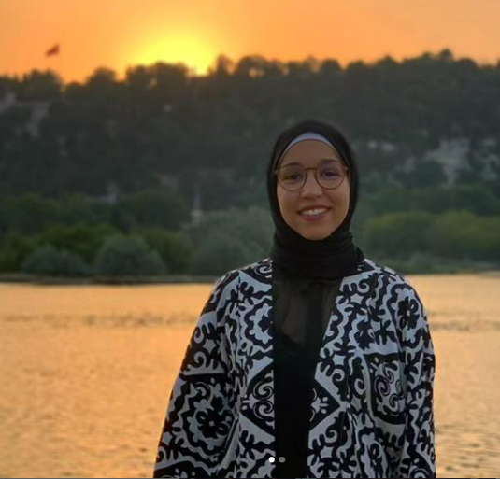

A Master's Degree student in Bioengineering from **Bahcesehir University (BAU), Istanbul, Turkey**. She carried out a Research Internship for 8 weeks during Winter 2023, March 6 - April 30th under the guidance of Dr Loganathan Rangasamy. She is currently finishing her masters in bioengineering. Currently, she is am a PhD Scholar in the Marie Skłodowska-Curie Actions Doctoral Networks Program, participating in the PhotoCaM Project focused on Computational Microscope

1. Mr. FASOGBON, Ilemobayo Victor



Mr. FASOGBON, Ilemobayo Victor, PhD scholar from Kampala International University, Uganda. He has done Research Internship under guidance of Dr Loganathan Rangasamy from 27th January to 10th March 2024.

1. 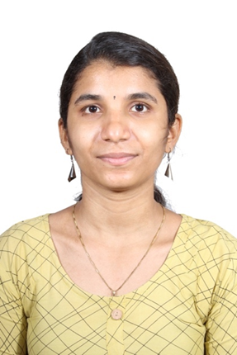RISHIKA S.

Rishika S, completed her M.Sc. from VIT Vellore in May, 2022.She had done her dissertation work in our lab under the Title “Design, synthesis and biological evaluation of novel dual PARP1/HDAC1 inhibitors”. After her M.Sc. she joined as a Project Associate in Syngene, Hyderabad. Currently she is doing her Ph.D. scholar in VIT.

1. 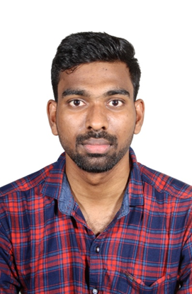VIGNESH A

Vighnesh A, completed his M.Sc. from VIT Vellore in May, 2022. he had done her dissertation work in our lab under the Title “Design, synthesis of mitochondria targeting photosensitizer for photodynamic therapy”. After his M.Sc. she joined as a Project Associate in Syngene, Hyderabad.

5.Hariprashanth K VIT

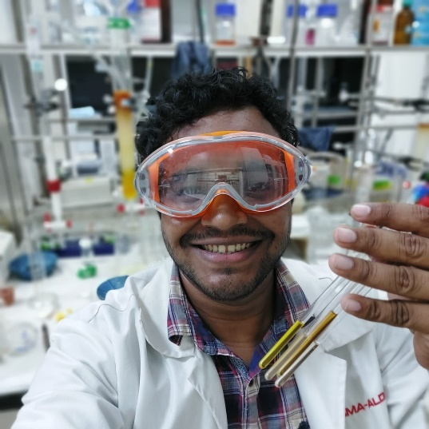

Hariprasath completed his undergraduate Degree in chemistry at Erode arts and Science College affiliated to Bharathidasan university. Then he pursued his postgraduate Degree in organic chemistry at VIT Vellore during 2021-2023. He completed his master thesis in 2023 tittle Ruthenium (II) Arene complex with pyridine quinoline anchoring ligands synthesis and anticancer studies in the Drug Discovery Unit group under the Supervision of Dr. Loganathan Rangasamy, School of Advanced Science (SAS). After his masters he joined Merck India as a research intern under SLS R&D team. He worked on PROTACs, Metabolites, SPPS and Carbohydrates. He completed his internship on September 2023.He joined Micro fluidic laboratory under prof. Wei-yu-Lin at Kaohsiung medical university, Taiwan. He mostly worked on Synthetic methodology development of organic compounds. His project titled was microwave assist C-H activation of novel benzoquinone derivatives and flow methods.

N. DINESH BABU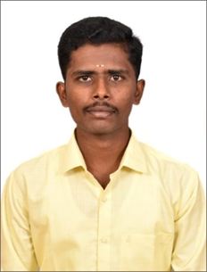

Dinesh completed his B.Sc. degree in KMG college of Arts and Science, Gudiyattam (2019-2022). He did his M. Sc degree in Vellore Institute of Technology, Vellore (2022-2024). During his masters he did a six-month project about the Synthesis and Characterization of Siderophore-Antibiotic Conjugate for treating bacterial infection under the guidance of Dr. Loganathan Rangasamy, Associate Professor, Centre for Biomaterials, Cellular and Molecular Theranostics (CBCMT), VIT. He has been selected as Technical Trainee in Apitoria Pharma Private Limited (100% subsidiary of Aurobindo Pharma Ltd.)

ISHAL AHAMED C

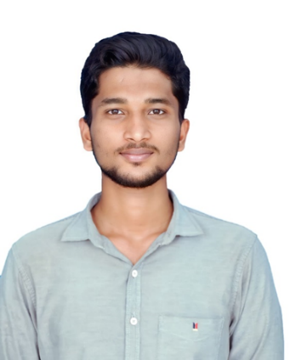

Ishal completed his bachelor’s degree in Islamiah College (Autonomous), Vaniyambadi (2019-2022). He done his master’s degree in Vellore Institute of Technology (VIT), Vellore (2022-2024). He completed his Master-thesis at Drug Discovery Unit (DDU), Centre for Biomaterials, Cellular and Molecular Theranostics (CBCMT), VIT Working on the project “Synthesis, Characterization and Biological Evaluation of Fibroblast Activation Protein Inhibitor (FAPI)” under the guidance of Dr. Loganathan Rangasamy, Associate Professor.He has been chosen as a Technical Trainee at Apitoria Pharma Private Limited, a wholly owned subsidiary of Aurobindo Pharma Ltd.

Invited Talks

1. Delivered an invited lecture on ‘’Principles of Early Drug Discovery’’ at Vels Institute of Science Technology and Advanced Studies VISTAS, Chennai, India, 05 April 2024.

2. Delivered an invited lecture on ‘’Bio-inspired Drug Delivery Systems: Targeted Agents for Cancer and Infections’’ at Vivekanandha College of Arts and Sciences For Women Autonomous, Erode, India, 15 September 2023.

3. Won the first prize in the “Grand Finale Cancer Hackathon 2023" for the topic "Peptide conjugated drug delivery for targeting Breast cancer stem cells" in the Cancer Hackathon conducted by Karpagam Academy of Higher Education, Startup TN, TICEL biopark, and TIDCO, 29, November 2023.

4. Inauguration Lecture, on Small molecule Drug Conjugates (SMDC) and PROteolysis targeting Chimeras (PROTACs): an Emerging Therapeutic Modality", in the association Inauguration (cheminitio-2023), organized by the Karpagam Academy of Higher Education, Coimbatore, Oct 18, 2023

5. Delivered an invited lecture on ‘’The emerging role of small molecules in targeted cancer therapy’’ at Government Arts College, Coimbatore. April 19, 2022

6. Delivered an invited lecture on Small Molecule Drug Conjugates: Guided Missiles Against Cancer at Dhanalakshmi Srinivasan University Samayapuram, Trichy, India. Janulary 06, 2023

7. Delivered an invited lecture on the Recent Spate of Bioconjugate Medicines at KSR College of Arts and Science for Women, Namakkal, Tamil Nadu and Bharath University Chennai Tamil Nadu, Erode, India, March 16-17,

8. Delivered an invited lecture on ‘’The emerging role of small molecules in targeted cancer therapy’’ at Government Arts College, Coimbatore. April 19, 2022

9. Delivered a guest lecture on ‘Small molecule Drug Discovery’ at Kongunadu Arts and Science College, Coimbatore, on March 29, 2021

10. Delivered a guest lecture on ‘Recent Advances in Tumor-Targeted Drug Conjugates’ Small molecule Drug Discovery’ at Karpagam Academy of Higher Education, Coimbatore, on Feb 25, 2021

11. Delivered 2 h Guest lecture for Master students on the Drug Discovery program offered by the University of San Pablo CEU, Madrid, Spain, Dec 16, 2020

12. Delivered invited talk https://mrs.digitellinc.com/mrs/sessions/32299/view Materials Science for COVID-19: A Global Discussion Between Scientists Nov 11, 2020 8:00am ‐ Nov 11, 2020 9:30am

13. Delivered an invited talk in International Webinar of Developing Biomaterails for the fight against COVID-19 organized by the Chinese Society For Biomaterials and US Society For Biomaterial, November 8, 2020

14. Delivered a talk on 'Coronavirus treatments, challenges, and opportunities’ at Einstein College of Arts and Science, Tirunelveli on August 01, 2020

15. Resource person for the five days Faculty Development Programme on “Challenging role of Chemistry in Drug Design and Development” (CCDD – 2K20) organized by the Department of Chemistry and Institution’s Innovation Council (IIC), K S Rangasamy College of Technology, Tiruchengode. Namakkal (Dt.), Tamil Nadu, India on August 08, 2020

16. Delivered a webinar on ‘In search of Coronavirus Treatments: Challenges and Opportunities’ at Nehru Institute of Engineering and Technology – Coimbatore on July 24, 2020

17. Delivered webinar on ‘In search for coronavirus treatments: challenges and opportunities’ at PSG College of Arts and Science, Coimbatore on May 21, 2020

18. Delivered a webinar on 'Developments of therapeutics and vaccines for covid-19' at Sri Ramakrishna College of Arts and Science, Coimbatore on May 12, 2020

19. Delivered a webinar on 'Coronavirus Research - Drugs and Diagnostics' at Bannari Amman Institute of Technology, Erode, Tamil Nadu on May 09, 2020

20. Delivered an invited talk at NIPER, Kolkata on ‘Ligand targeted, vehicle-free delivery of microRNAs for the treatment of cancer’, August 13, 2019.

21. Delivered an invited talk at KSR-Global Nano Research Networks -Special lecture series on ‘Receptor targeted delivery of microRNAs for the treatment of cancer’, August 14, 2019, KSR Institutions, Tamil Nadu, India

22. Delivered a Guest talk at VIT, Vellore on ‘Ligand targeted, vehicle-free delivery of microRNAs for the treatment of cancer’, August 21, 2019.

23. Delivered a Guest talk at Madras Christian College, Chennai on ‘Ligand targeted, vehicle-free delivery of microRNAs for the treatment of cancer’, August 22, 2019.

24. Delivered an invited talk at Central University of Tamil Nadu, Thiruvarur on ‘Ligand targeted, vehicle-free delivery of microRNAs for the treatment of cancer’, August 26, 2019.

25. Delivered an invited talk at Bharathidasan University on ‘Targeted treatment of cancer’, August 27, 2019.

26. Delivered an invited talk at Manonmaniam Sundaranar University on ‘Targeted Drug design for treatment of cancer’, August 28, 2019.

27. Delivered a invited talk at National Engineering College, Kovilpatti on ‘Targeted Drug design for treatment of cancer’, August 28, 2019.

28. Delivered an invited talk at National College, Trichy on ‘Small molecule drug design for treatment of cancer’, August 29, 2019.

29. Delivered a Guest Lecture on ‘Receptor targeted delivery of miRNA therapeutics for cancer treatment’ at Department of Chemistry, Karunya University, Coimbatore on September 04, 2018

30. Invited talk at the joint India-UK International Conference on "Advanced Nanomaterials for Energy, Environment and Healthcare Applications” (ANEH-2019), February 4-6, 2019, at Bishop Heber College, Tamil Nadu, India

31. Invited talk at the joint India-UK International Conference on "Advanced Nanomaterials for Energy, Environment and Healthcare Applications” (ANEH-2018), August 31 & September 1, 2018, at KSR Institutions, Tamil Nadu, India

32. Delivered a Guest Lecture at the Department of Chemistry, Bharathiar University, India on ‘Receptor targeted delivery of small molecule/miRNA therapeutics for cancer treatment’, September 03, 2018

33. Delivered a Guest Lecture on ‘Higher Education Opportunities of Chemistry in India and Abroad’ at Chemistry Association Inaugural Function, Department of Chemistry, PSG College of Arts and Science, Coimbatore, September 05, 2018

34. Delivered a Guest Lecture on ‘Receptor targeted delivery of small molecule/miRNA therapeutics for cancer treatment’ at PSG Institute of Advanced Studies (PSGIAS), Coimbatore on September 06, 2018

35. Delivered a Guest Lecture on ‘Receptor targeted delivery of small molecule/miRNA therapeutics for cancer treatment’ at Department of Chemistry, Karpagam Academy of Higher Education, Coimbatore on September 07, 2018

28. Invited talk at the International Symposium on ‘Advanced Functional Materials’, Gobi Arts and

Science College, Gobi, August 27, 2018.

36. Invited talk at the National Seminar on ‘Recent Trends in Chemical Sciences’, Sri Ramakrishna College of Arts and Science, Coimbatore, February 23, 2018

37. Invited talk at the Science Academies’ Three-day Lecture Workshop on ‘Emerging Trends in Chemical Sciences, Bharathiar University, Coimbatore, February 15-17, 2018.

Interview in Media

1. Live Interview with Dr. Loganathan Rangasamy on ‘Corona Virus and Medicines’ in Kalainar TV from 2.30 PM to 3.00 PM April 16, 2020 (<https://www.youtube.com/watch?v=oMAqLqupN2E&feature=youtu.be>)

Contribution to National and International Conferences

1. Poster presentation at International Conference on Infectious Diseases & Antimicrobial Resistance - MICROSUMMIT-2023 at the Saveetha Dental College and Hospitals (SDC), Saveetha Institute of Medical and Technical Sciences (SIMATS) 28th and 29th of July 2023

2. Poster presentation at BIORemedi 2022 International conference on Biomaterials Regenerative Medicine and Devices held at IIT Guwahati, India from Dec 14th - Dec. 18th, 2022.

3. Participation in Annual Conference of Indian Association for Cancer Research (IACR) conducted by IACR held at ACTREC-TMC from the 12th to 16th of January, 2023.

4. Poster presentation at 6th European Chemical Biology Symposium and the meeting of the

EuChemS Division “Chemistry in Life Sciences” (LS-EuChemS), on CX4945-based scaffolds for

the synthesis of dual inhibitors of Protein Kinase 2 (CK2) and Histone Deacetylases(HDACs)’ 3-5

April 2019, Madrid, Spain.

5. Poster presentation at 6th Young Researchers Symposium, Madrid, Spain protein kinase (CK2)

and histone deacetylase (HDAC) hybrid Inhibitors for cancer therapy, June 21, 2019.

6. Flash presentation at 19th meeting “New challenges in drug discovery”, Vitoria-Gasteiz , Spain on

‘Pharmacophore Hybridization to Discover Novel CK2/HDAC Dual Inhibitors’ July 8-11, 2019

7. Poster presentation on ‘Dual CK2/HDAC Inhibitors as a New Strategy For Multi-Targeting

Antitumor Drug Discovery’ at V Young Researchers Medicinal Chemistry Symposium, organized

by the Spanish Society of Medicinal Chemistry, Madrid, Spain, June 22, 2018

8. Poster presented on ‘In silico identification of bifunctional CK2/HDAC inhibitors following a

structure-based drug design approach’ at VI SEQT Summer School, organized by the Spanish

Society of Medicinal Chemistry and Janssen, Toledo, Spain, June 19-21, 2018

9. Poster presentation on ‘Structure-based Drug Design of Dual Inhibitors of Protein Kinase 2 (CK2)

and Histone Deacetylases (HDACs)’ at VIII Meeting of the Paul Ehrlich EuroPhD Network, Porto,

Portugal, 12th-14th July, 2018

10. Delivered an oral presentation at Indo-French seminar on bioinorganic approaches to current health problems, Department of Chemistry, Pondicherry University, March 24-28, 2014

11. Poster presented in the 14th CRSI National Symposium at CSIR-NIIST, February 2-5, 2012.

12. Best Poster Award and Cash Award at the Asian Conference on Coordination Chemistry (ACCC3-2011), IIT Kanpur, October 17 – 20, 2011.

13. Participated in the seminar on Recent developments in Chemistry’, School of Chemistry, Bharathidasan University, Tiruchirappalli, 29 August 2011.

14. Poster presentation at the International Symposium on Frontiers in Inorganic Chemistry (FIC-2010), Kolkata, December 11 – 13, 2010.

15. Oral presentation on “DNA Binding and DNA Cleavage, and Anticancer Activity of Mixed-Ligand

Copper(II) Complexes of Diimines” at the National Seminar on Recent Advances in Inorganic and

Nano Chemistry (RAINC – 2010), Madurai Kamaraj University, Madurai, March 29 – 30, 2010.

16. Best Poster Award at the School and Symposium on Advanced Biological Inorganic Chemistry

(SaBIC-2009), Tata Institute of Fundamental Research (TIFR), Mumbai, November 2 – 7, 2009.

17. Best Poster Award in the International Conference on Coordination and Organometallic Chemistry

(ICCC2009)”, Bharathiar University, Coimbatore, March 19 -21, 2009. Abs. p. 94.

18. Participated in the 10th CRSI National Symposium at IISc, Bangalore, February 1-3, 2008.

19. Presented a poster on “Nanotechnology and its application” at the National Seminar on “Recent Trends in Chemistry” at Nirmala College for Women, Coimbatore, March 1– 2, 2007.

20. Presented an oral presentation and Poster on “Microwave synthesis - An ultimate tool for green

synthesis”, at the National level symposium on Green Chemistry (HORIZON-2007) at the National

Institute of Technology, Tiruchirappalli, October 5 – 6, 2007.

21. Participated in National conference on “Recent Advances in Metal-Organic Chemistry and Material Science” (RAMMS-2007), held at PSG College of Technology, Coimbatore on 5th to 7th July, 2007

22. Oral presentation on “Microwave Assisted Organic Reactions” at the National Level Seminar on

“Environment Friendly Chemical Reactions & Synthesis” at Andhra Loyola College, Vijayawada,

September 14-17, 2005.

23. 1st Prize in the State Level Paper Presentation on “Structure & Mechanism of Ion Channels” at

Thiyagarajar College of Arts and Science, Madurai, Feb 2005.

24. Outstanding Performance Award, academic year 2004-2005, at PSG College of Arts and

Science, Coimbatore.

**Participation in special lecture courses taught by eminent professors from Indian universities and research institutions (fully funded selection based on applicant achievements)**

1. Science academies sponsored Lecture workshop on “Emerging Trends in Chemistry”, Queen

Mary’s College, Chennai, December 02 – 04, 2011.

2. Science academies sponsored Lecture workshop on “Frontiers in Bioinorganic Chemistry”,

Bharathidasan University, Tiruchirappalli, February 24 – 27, 2010.

3. Science academies sponsored Lecture workshop on “Frontiers in Chemistry”,

National College, Tiruchirappalli, March 13-14, 2009.

4. Science academies sponsored Lecture workshop on “Probing Electronic states in Molecules

and Molecular Materials”, Bharathidasan University, Tiruchirappalli, September 24 – 27, 2008

5. Science and Engineering Research Council (SERC) sponsored lecture workshop on “Chemical

Thermodynamics” (CHEMTHERM-2007), organized by Indira Gandhi Centre for Atomic

Research (IGCAR), Kalpakkam, January 3-7, 2007

Other Roles and Responsibilities

* National Accreditation Board for Testing and Calibration Laboratories (NABL) coordinator for CBCMT
* Teaching Learning Centre of Excellence (TLCE), VIT – CBCMT Coordinator
* IBTN-India Student Chapter – Advisor
* CBCMT Performance Evaluation Committee member
* CBCMT Budget Committee member
* Member, Institutional Ethical Committee (IEC), Sri Narayani Hospital & Research Centre, Vellore
* Member of Board of Studies, Dept of Chemistry, PSG College of Arts and Science, Coimbatore